WEEK 5 : CI/CD Pipeline with Azure DevOps
Pre-requisites:
- Ensure SSH Public Key or Personal Access Token (PAT) for HTTPS is already configured.
- Install Git, Python, and VS Code / any IDE.
- Have your project folder ready on your local system, which includes:
  - Python file for expense alert
  - Azure pipeline YAML file

Step 1: Create Python and YAML Files in Local Project
- Create a Python file (e.g. report_generator.py)
Example:
# report_generator.py
import pandas as pd
# === Load Week-4 cleaned data files ===
students = pd.read_csv('students.csv')
courses = pd.read_csv('courses.csv')
enrollments = pd.read_csv('enrollments.csv')
progress = pd.read_csv('progress.csv')
# === Consolidate the data ===
df = (enrollments
.merge(students, on='student_id')
.merge(courses, on='course_id')
.merge(progress, on=['student_id','course_id'])
.rename(columns={'progress':'completion_percent'}))
# === Filter for < 50% progress ===
low_progress_df = df[df['completion_percent'] < 50]
# === Save the weekly report ===
low_progress_df.to_csv('weekly_low_progress_report.csv', index=False)
print("Report saved as weekly_low_progress_report.csv")

2.Create a YAML file for Azure Pipeline (e.g. azure-pipelines.yml)
Example:
trigger:
branches:
include:
- main

schedules:
- cron: "0 9 * * 1"
displayName: Weekly Report
branches:
include:
- main
always: true

pool:
vmImage: 'ubuntu-latest'

steps:
- task: UsePythonVersion@0
inputs:
versionSpec: '3.x'

- script: |
pip install pandas
python report_generator.py
displayName: 'Generate Weekly Progress Report'

- task: PublishBuildArtifacts@1
inputs:
PathtoPublish: 'weekly_low_progress_report.csv'
ArtifactName: 'WeeklyReport'
publishLocation: 'Container'

Step 2: Create a New Azure DevOps Project
- Go to Azure DevOps Portal.
- Click New Project → Provide name and visibility → Click Create.
- Navigate to Repos → Click Clone → Copy the SSH URL.
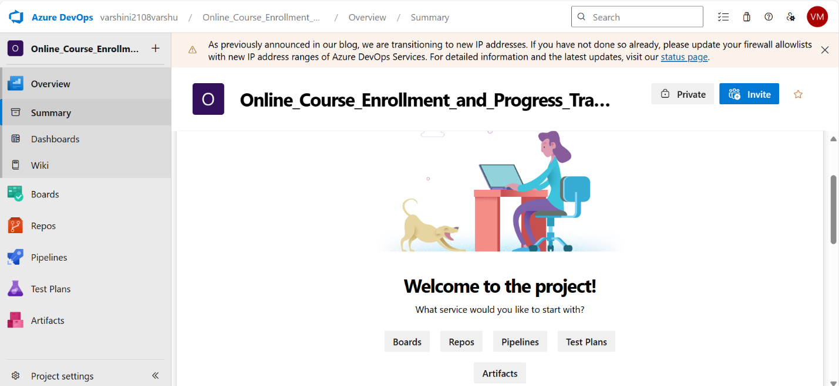
Step 3: Push Local Project to Azure Repo via SSH
Open Command Prompt / Git Bash, then run the following:
# Go to the directory where your local project exists
cd path\to\your\project-folder
# Initialize git repository
git init
# Add files to git
git add .
# Commit the files
git commit -m "Initial commit"
# Add Azure DevOps repo as remote (replace with your SSH link)
git remote add origin git@ssh.dev.azure.com:v3/YourOrg/YourProject/YourRepo

# Push the code to Azure repo
git push -u origin main
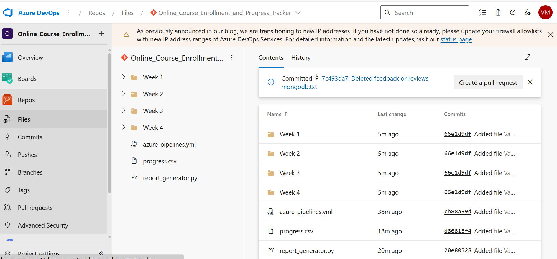

Step 4: Configure and Run the Azure Pipeline
- Go back to your Azure DevOps project.
- Navigate to Pipelines → Click Create Pipeline.
- Choose:
  - Code in Azure Repos Git
  - Select your repository
  - Choose "Existing Azure Pipelines YAML file"
- Select:
  - Branch: main
  - Path: /devops/azure-pipelines.yml
- Click Continue, then Run the pipeline.

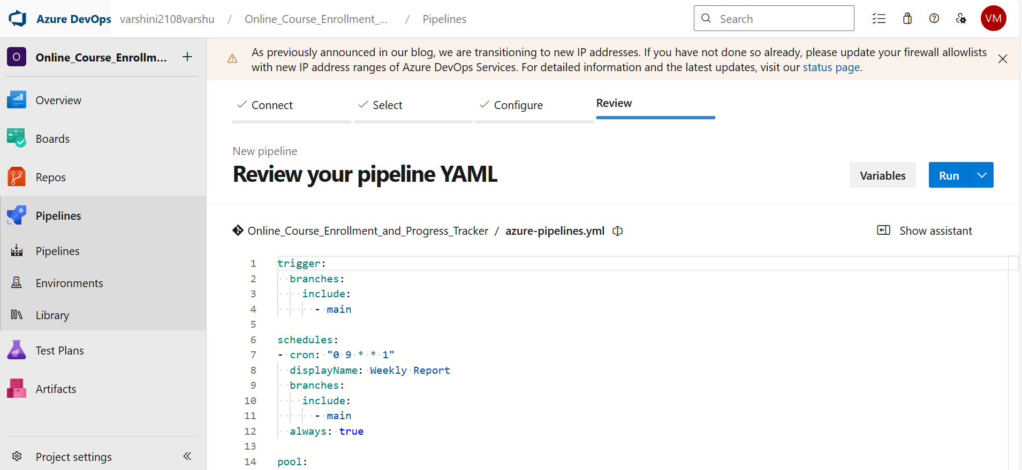

✅ Final Output
- The pipeline will automatically run every Monday at 9 AM UTC.
- It will generate `weekly_low_progress_report.csv` with students having less than 50% progress.
- The CSV will be available as a build artifact in Azure DevOps.
